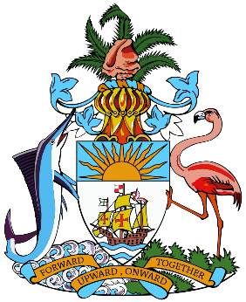

***We are now in the Caribbean dry season, and a short-term drought warning should be considered for the Northern Bahamas and a drought watch for the Central Bahamas.***

**March to May 2025 Rainfall Outlook**

***This period marks the summer portion of the Caribbean wet season and heat season. The tropical North Atlantic Ocean is forecast to remain unseasonably warm – albeit not at record levels as experienced in 2023 and 2024. Unusually high air temperatures will most likely prevail in many locations and the occurrence of significant heat stress is expected to evolve. The risk of severe weather impacts, including flooding, flash floods, and cascading impacts is expected to be even higher than usual, amounting to unusually copious wet season rainfall. Warmer than usual ocean temperatures around and east of the Caribbean typically drive an active hurricane season. However, severe weather activity may be more erratic if Saharan dust intrusions into this region are very frequent.***

**Climate Outlook June to August 2025**

***The night-time and daytime minimum temperatures will likely be higher than usual in most areas and maximum temperatures will likely be as high as usual or higher. Episodes of hazardous heat could appear in April & May, with increased risk in areas that are windsheltered and/or in drought.***

**March to May 2025 Temperature Outlook**

***Rainfall amounts in the Bahamas March-April-May are likely to be the usual or less in The Bahamas. However, the month of May will transition into the wet season.***

***The information contained herein is provided with the understanding that The Bahamas Department of Meteorology makes no warranties, either expressed or implied, concerning the accuracy, completeness, reliability, or suitability of the Bulletin.***

**March to May 2025 Drought Outlook**

**BAHAMAS TEMPERATURE & RAINFALL OUTLOOK**

**DISCLAIMER**